DBMS ASSIGNMENT-1
Name - Harsh HemalKumar Mehta
Student Id - 202412048

1.Select all users with the first name "Rahul".
-> select * from "EC_DB".users where first_name = 'Rahul'; (There Is no recored of Rahul in data.)
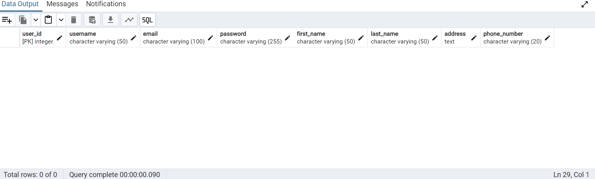

2. Select all roducts that cost more than 5000.
-> select * from "EC_DB" .products where price>5000 ;
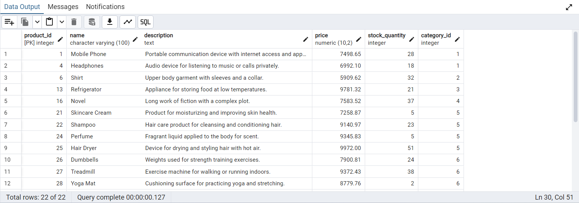

3. Select all orders that are in the "Shipped" status.
-> select * from "EC_DB" .orders where status='Shipped' ;
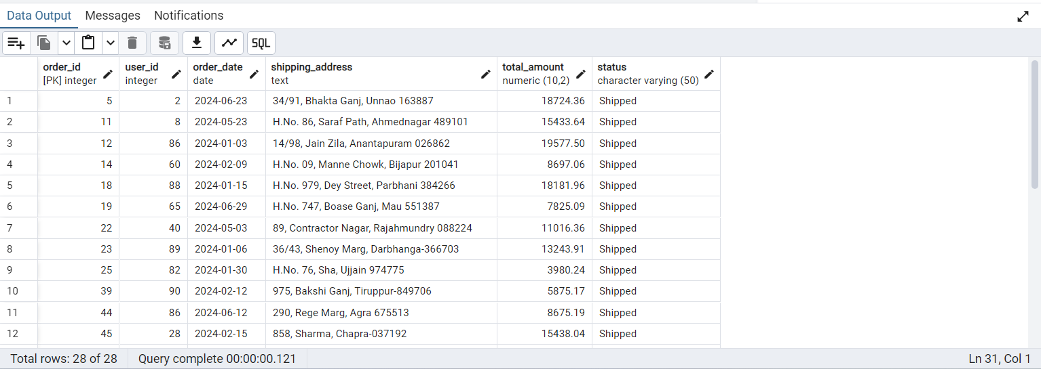

4. Select all reviews with a rating of 5.
-> select * from "EC_DB".reviews where rating=5;
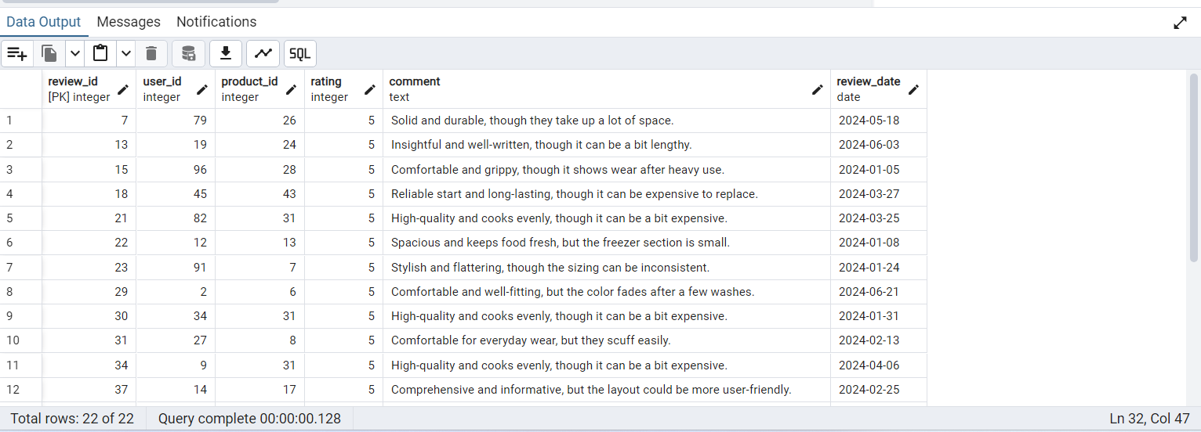

5. Select all categories that have "Books" in their name.
-> select * from "EC_DB".categories where category_name = 'Books';
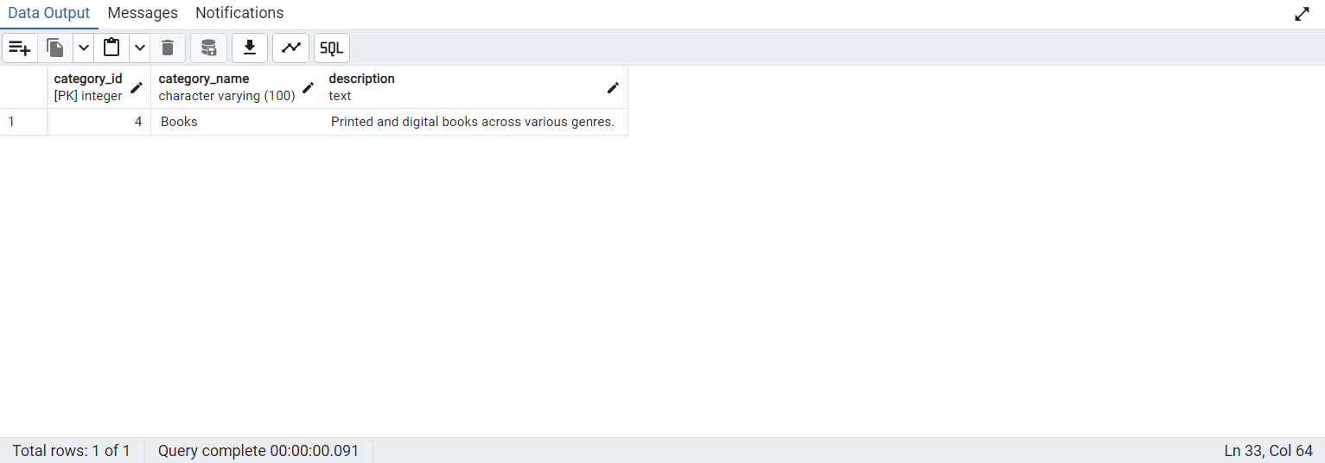

6. Select all products that belong to category ID 3.
-> select * from "EC_DB".categories where category_id = 3;
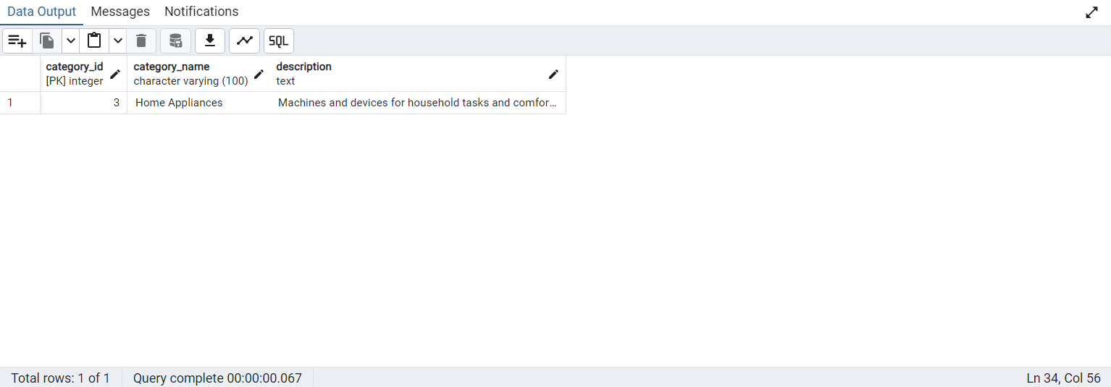

7. Select all users whose last name starts with "Singh".
-> select * from "EC_DB".users where last_name like 'Singh%';
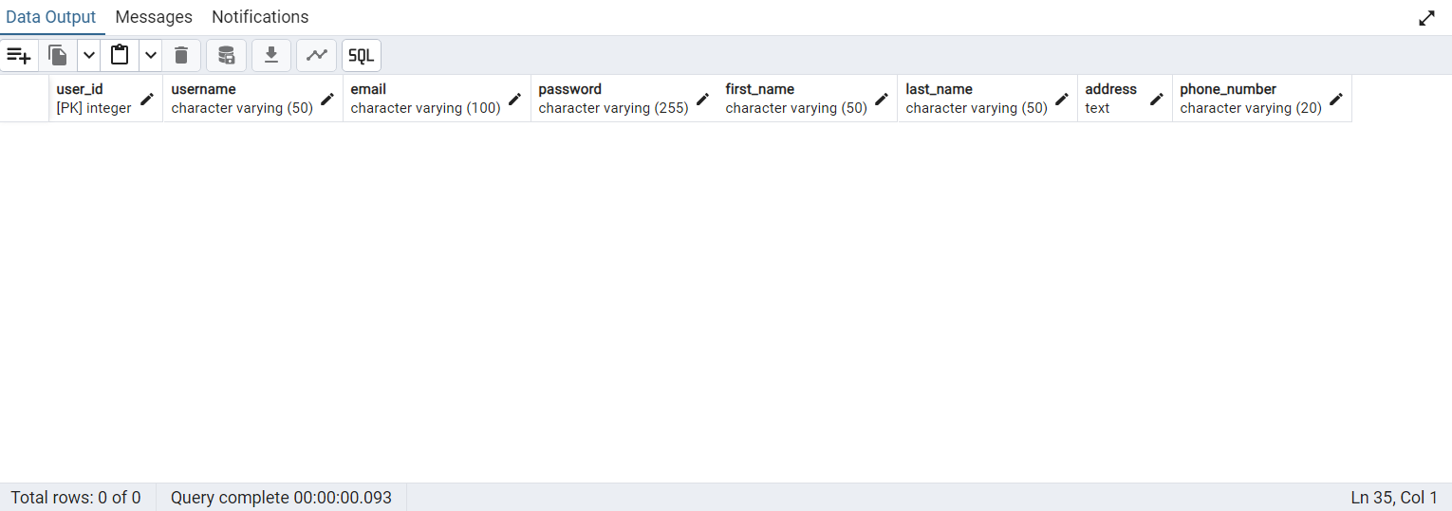

8. Select all orders placed by user ID 10.
-> select * from "EC_DB" .orders where user_id=10 ;
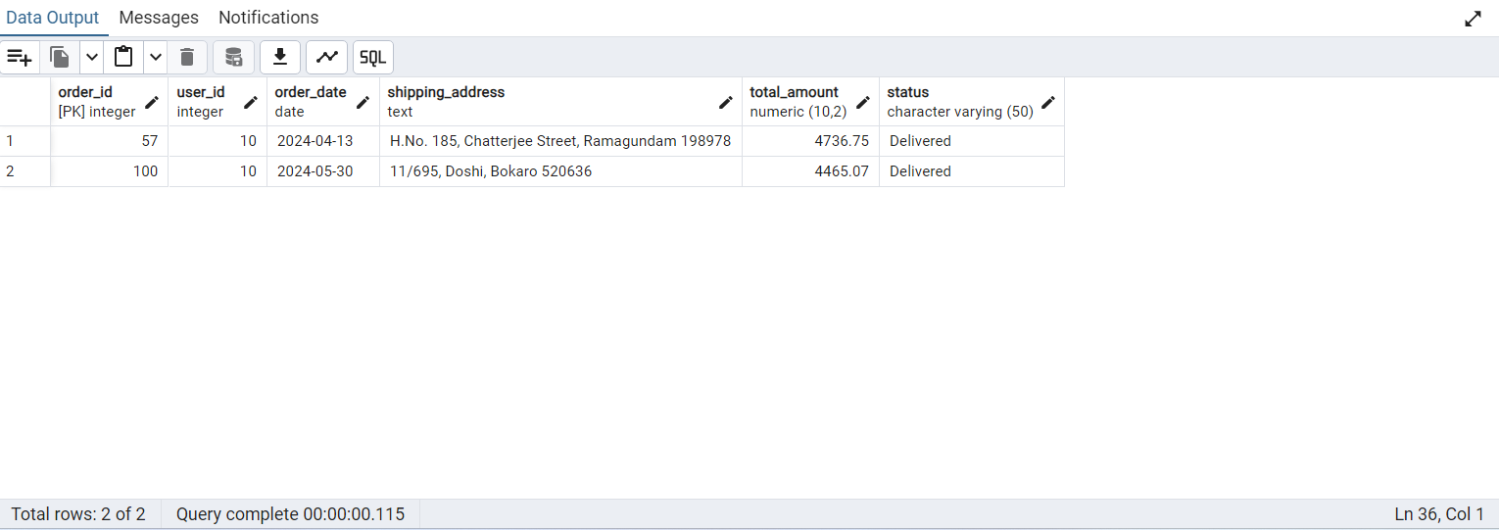

9. Select all products that have less than 10 items in stock.
-> select * from "EC_DB" .products where stock_quantity<10 ;
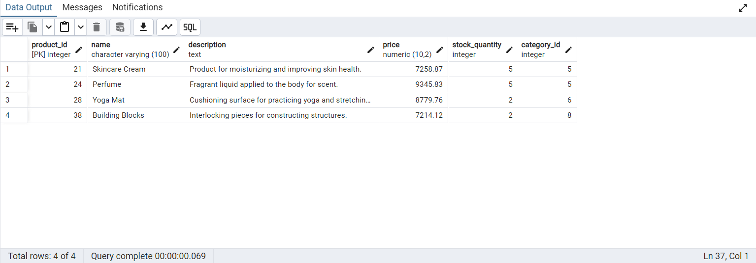

10. Select all reviews written in the year 2024.
-> select * from "EC_DB".reviews where review_date > '2023-12-31';
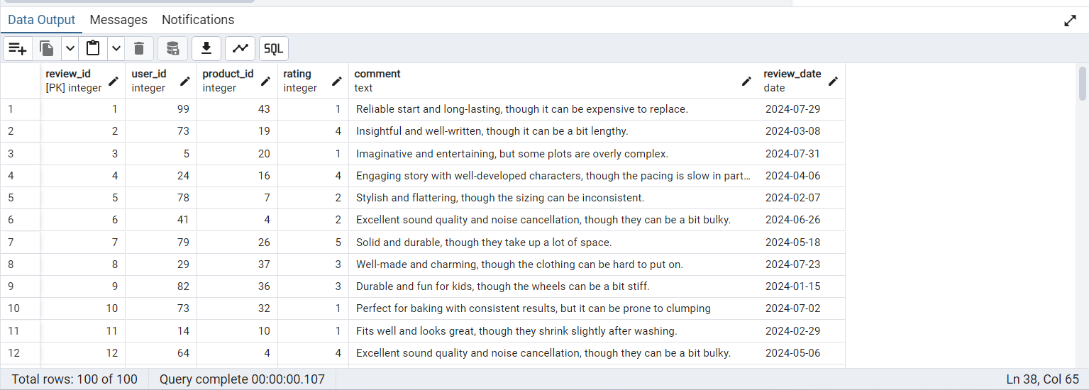

11 . Select all users with email addresses from "gmail.com".
-> select * from "EC_DB".users where email like '%gmail.com';
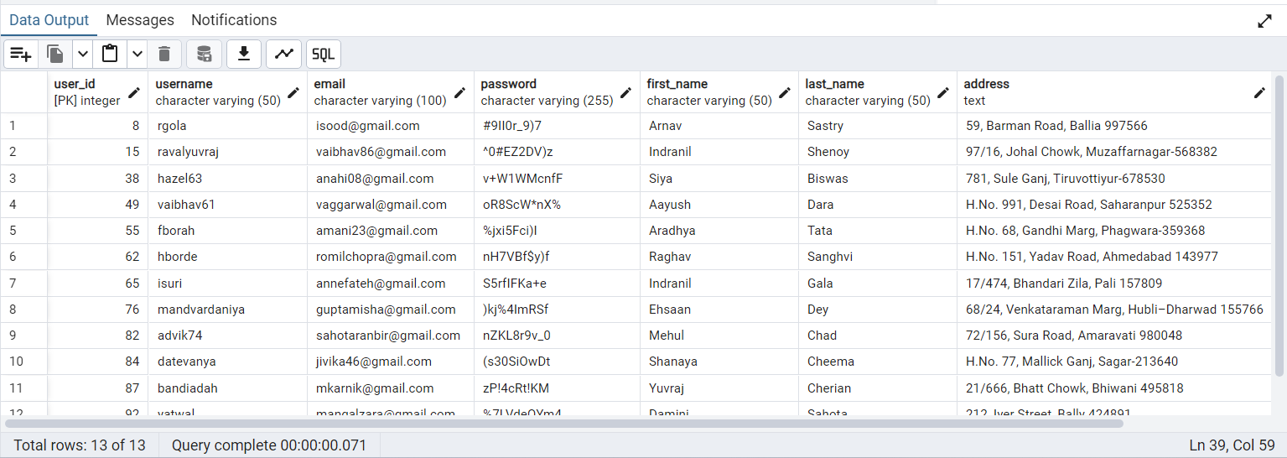

12. Select all products with the name "Laptop".
-> select * from "EC_DB" .products where name = 'Laptop' ;
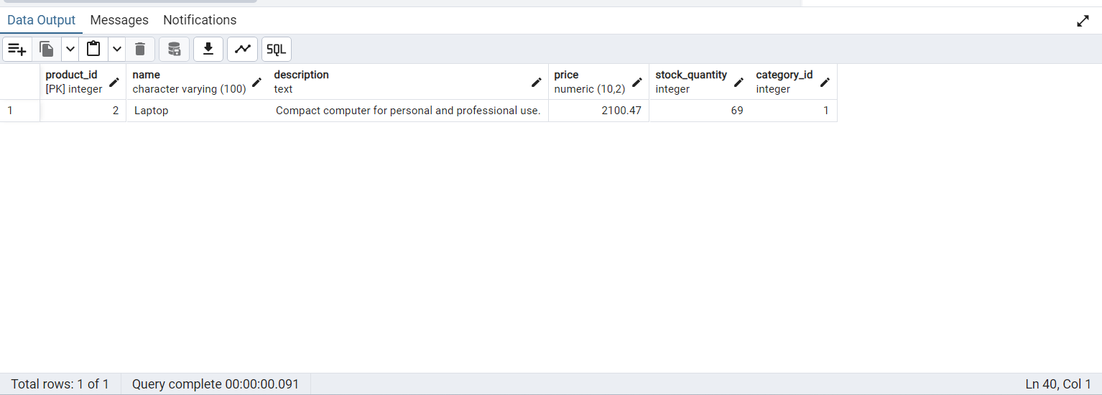

13. Select all orders with a total amount greater than 10000.
-> select * from "EC_DB" .orders where total_amount>10000 ;
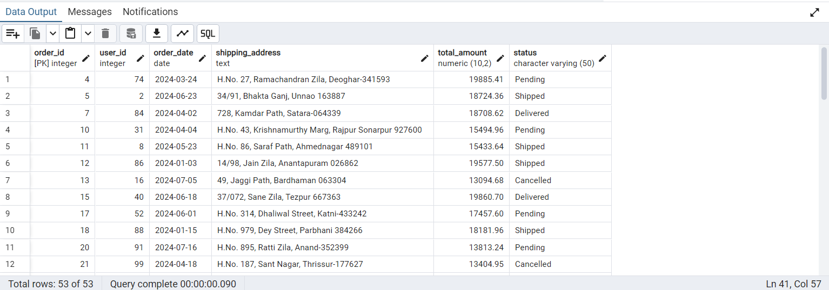

14. Select all order details where the quantity ordered is greater than 5.
-> select * from "EC_DB" .order_details where quantity>5 ;
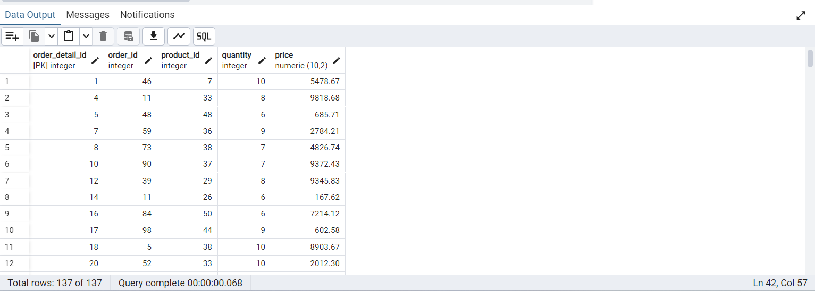

15. Select all users who live in "Mumbai".
-> select * from "EC_DB".users where address like '%Mumbai%' ;
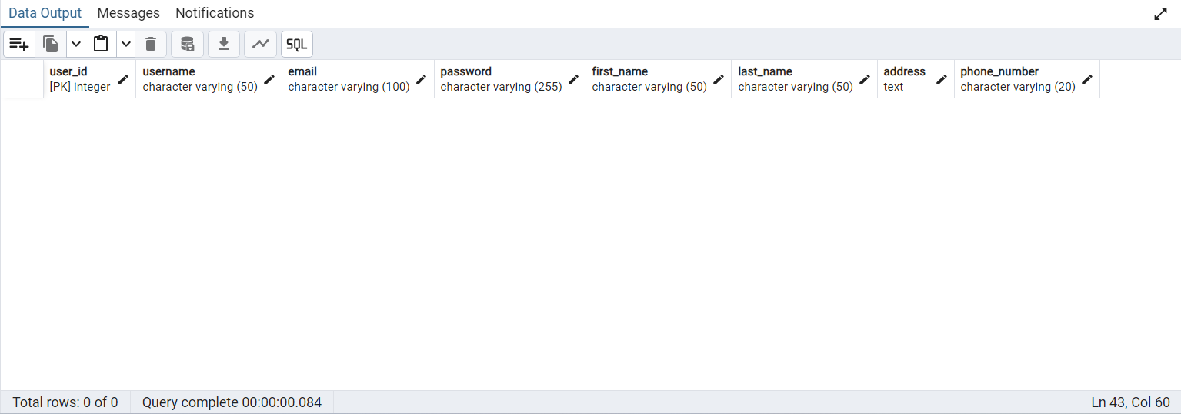

16. Select all categories with descriptions containing the word "technology".
-> select * from "EC_DB".categories where category_name like '%Home%';
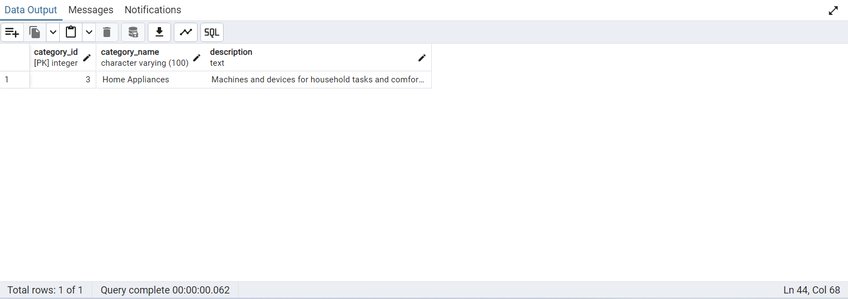

17. Select all products that belong to the "Electronics" category.
-> select product_id , name , "EC_DB".products.description , price , stock_quantity , "EC_DB".products.category_id from "EC_DB".products,"EC_DB".categories where "EC_DB".categories.category_name = 'Electronics'; ;
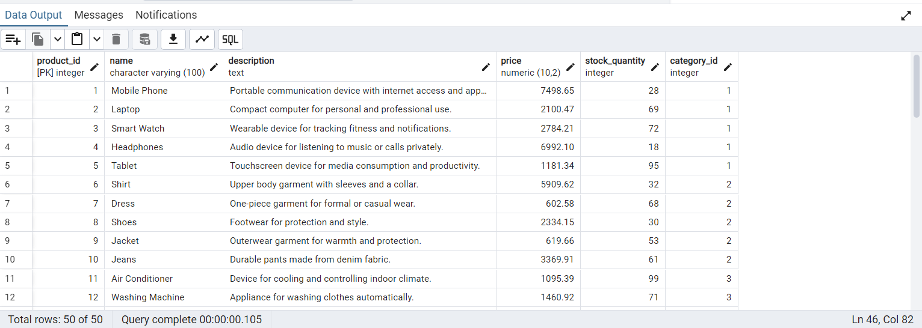

18. Select all orders placed on "2024-01-01
-> select * from "EC_DB" .orders where order_date='2024-01-01' ;
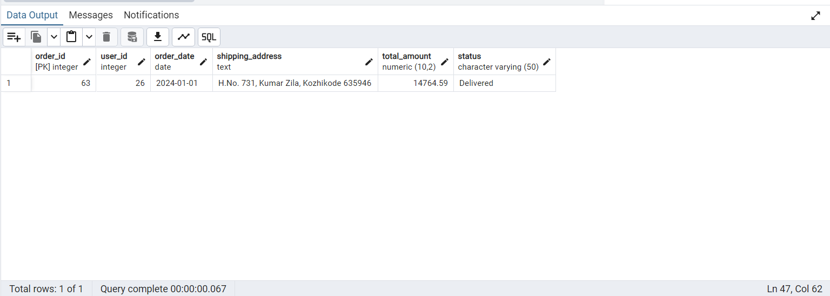

19. Select all reviews with the comment containing the word " though ".
-> select * from "EC_DB".reviews where comment like '%though%';
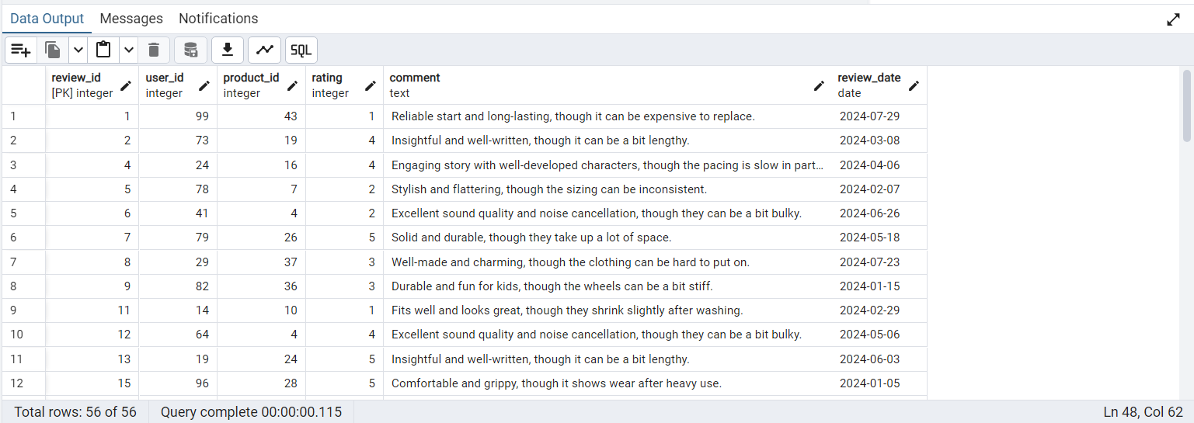

20. Select all users whose phone number starts with "+91".
-> select * from "EC_DB".users where phone_number like '+91%';
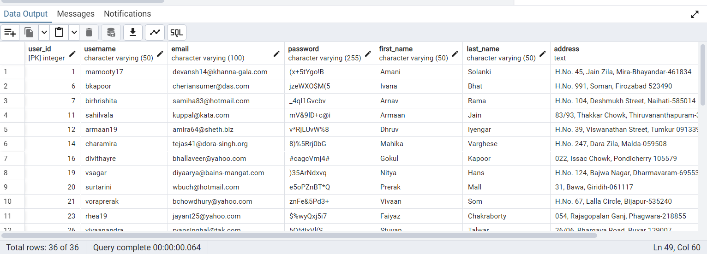

THE END

